Closure in JavaScript

[Anil Singh](https://www.blogger.com/profile/09359926778482233933)  [5:08 AM](http://www.code-sample.com/2015/06/closure-in-javascript.html)

**[What is closure in JavaScript?](http://www.code-sample.com/2015/06/closure-in-javascript.html" \t "_blank)**

While you create the JavaScript function within another function and the inner function  freely access all the variable of outer function. i.e.

[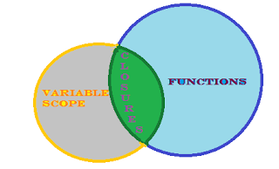](http://4.bp.blogspot.com/-j4Ona1rFvG0/VXZpHbhDvGI/AAAAAAAAGGU/P7oZqRVzSqo/s1600/closures%2Bin%2Bjavascript.png)

[How to create closure in JavaScript?](http://www.code-sample.com/2015/06/closure-in-javascript.html)

function ourterFun(i) {

    var var1 = 3;

    function innerFun(j) {

        console.log(i + j + (++var1)); // It will return the 16.

    }

    innerFun(10);

}

ourterFun(2); // Pass an argument 2

The output will get 16 because *innerFun()* function can access to the argument "i" & variable "*var1"* but both are define in the *outerFun()* function that is closure.

That means simply accessing variable outside of your scope create a [closure](http://www.code-sample.com/2015/06/closure-in-javascript.html).

// OR Other WAYS

function ourterFun(i) {

    var var1 = 3;

    return function (j) {

        console.log(i + j + (++var1)); // It will return the 16.

    }

}

var innerFun = ourterFun(2); // innerFun() function is now a closure.